Princess Sumaya University for Technology
King Abdullah II Faculty of Engineering
Electrical Engineering Department



Embedded Systems
Final Project Report
Autonomous Robot for Multi-Zone Navigation

Authors: |  | Supervisor:
Rania Jamjoum  Lara Qasmieh  Mohammad Al-Nsour | 20220959  20220211  20220576 | Prof. Esam  Al-Qaralleh
January 13, 2026
Abstract
This project presents the successful design and implementation of an autonomous mobile robot capable of navigating a multi-section challenge track. The robot follows a black line, handles curved segments, detects and reacts to a dark tunnel, avoids obstacles using an ultrasonic sensor, climbs a bump, and finally stops in a defined parking zone. Infrared sensors are used for line tracking, a light sensor at the top front of the robot detects tunnel darkness, and an ultrasonic sensor and infrared sensor measure distance to obstacles. The motors are driven by a motor driver module using PWM signals generated by a microcontroller. Additional components such as a buzzer, LED indicator, and reset button are integrated to enhance interaction and feedback. Experimental results show that the robot performs reliably in all zones after tuning sensor thresholds and motor speeds.
Full photo of robot:
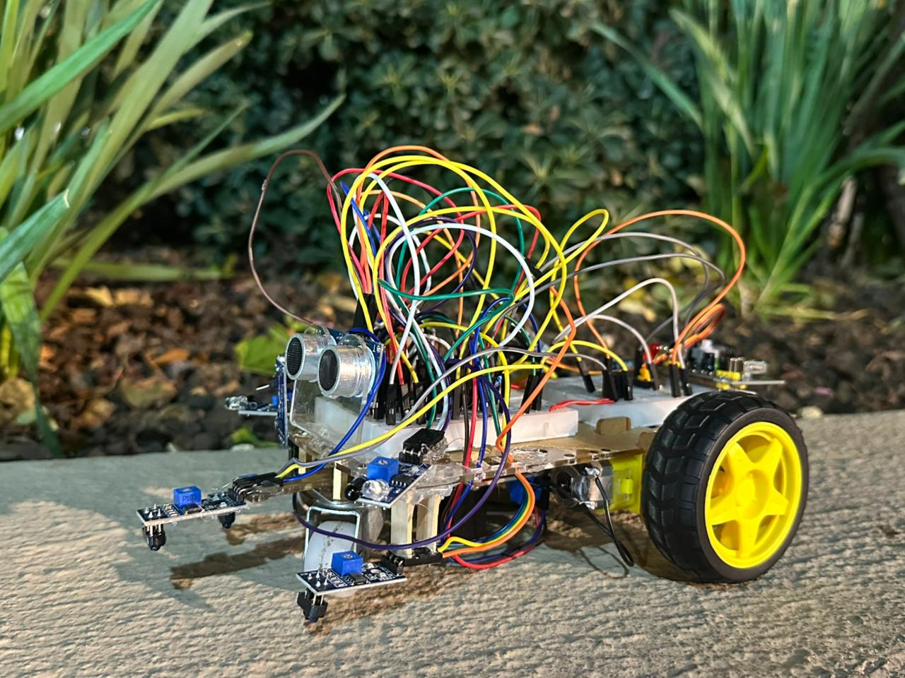

Table of Contents
Introduction & Background 3
Design 5
Mechanical Design 5
Electrical Design 6
Software Design 8
1. Line-Following Behavior 8
2. Tunnel Detection and Response 9
3. Obstacle Zone Behavior 9
4. Bump Zone Behavior 9
5. Parking Zone Behavior 9
Results 10
Conclusion 11
APPENDEX 11
Final Source Code 11
YouTube Video Link 11
GitHub Link 11

Introduction & Background
Autonomous robots that can follow predefined paths and react to their surroundings are widely used in industrial automation, material handling, and educational environments. Line-following robots are especially useful as they demonstrate real-time sensing, decision making, and control in a relatively simple physical setup.
In this project, a mobile robot is designed to complete a track divided into several zones:
- Line-following zone: the robot follows a black line through straight and curved sections.
- Tunnel zone: the robot enters a dark tunnel and detects reduced light using a light sensor.
- Obstacle zone: the robot uses an ultrasonic sensor and IR sensors to detect obstacles in front of it and reacts safely.
- Bump zone: the robot climbs a raised section of the track while maintaining stability and line tracking.
- Parking zone: the robot slows down and stops at a final target position, effectively parking at the end of the track.
These zones require the robot to combine multiple sensors and control strategies. Infrared sensors are used to distinguish the line from the background surface, the light sensor detects darkness in the tunnel, and the ultrasonic sensor measures distance to obstacles. The microcontroller processes these inputs and generates PWM signals to control two independent DC motors through a motor driver.
This report describes the design, implementation, and performance of the robot, focusing on mechanical layout, electrical connections, and the software algorithm that coordinates all zones.

Track diagram:
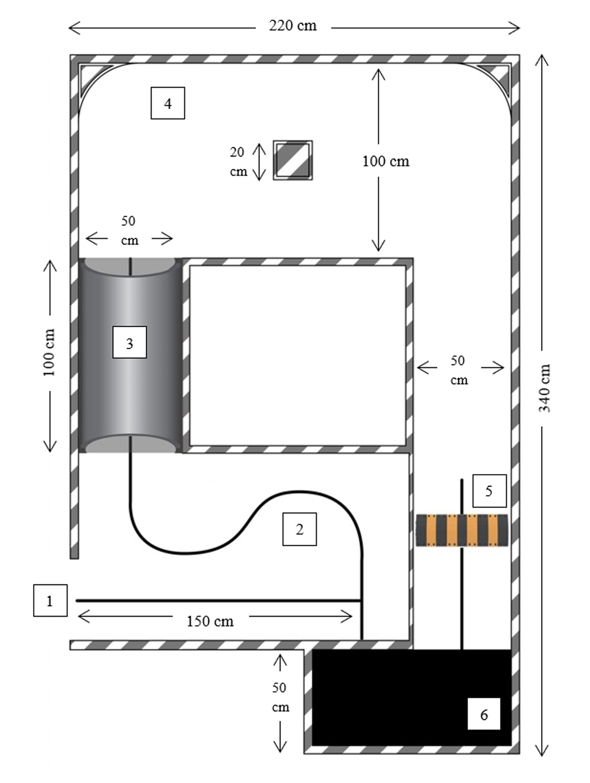

Design

Mechanical Design
The robot base is built using a lightweight platform that supports all mechanical and electronic components. Two DC geared motors are placed symmetrically on the left and right sides to provide propulsion and turning. A small free wheel at the front allows smooth rotation and helps the robot maintain balance when transitioning over the bump.
Two IR line sensors are placed at the front edge of the robot, close to the ground, so they can accurately detect changes between the black line and the surrounding surface. The light sensor is placed at the top front of the robot, allowing it to sense when the robot enters the darker tunnel region. The ultrasonic sensor is placed at the front and aligned in the forward direction and IR sensors to detect obstacles during the path navigation zone. A small LED is placed on the robot to indicate that the system is powered and running.
A small servo motor is connected to a flag. After the robot completes the final parking zone, this servo raises the flag as a clear visual indicator that the task is successfully completed.
The robot is designed so that most of the weight stays low and balanced between the two wheels. This helps the robot stay stable while moving and prevents it from falling over when going up the bump. The base is also high enough from the ground so the robot can pass over the bump smoothly without touching it.
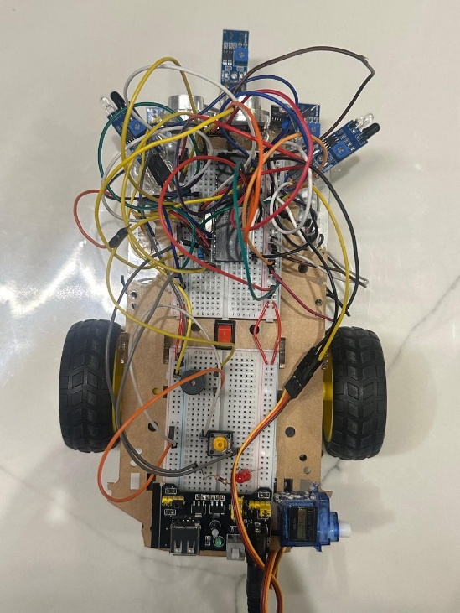
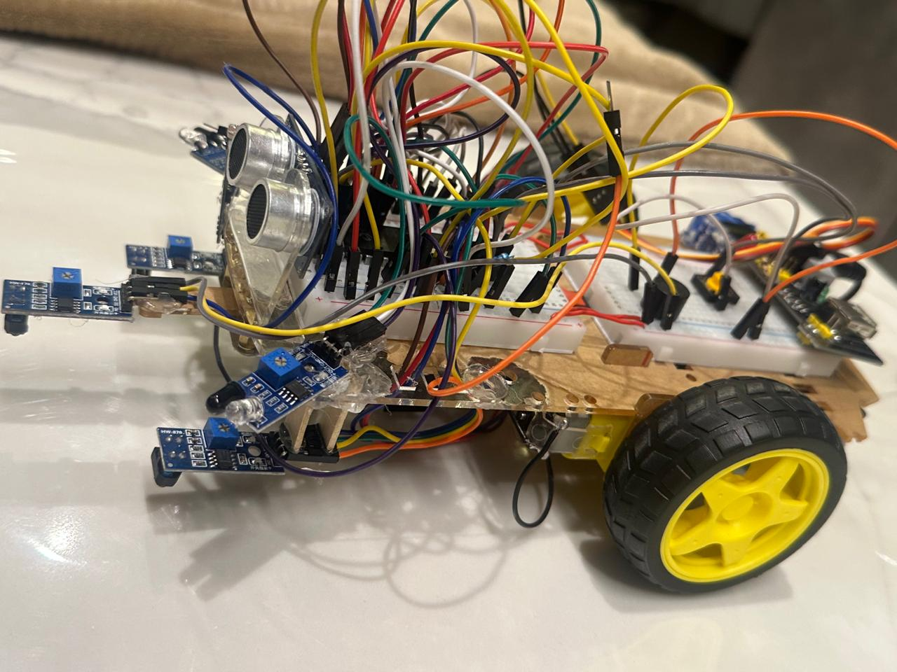

Electrical Design
The electrical system of the robot includes all the sensors, the microcontroller, the motor driver, and the output indicators. All components share a common ground and receive power from the same regulated supply to ensure stable operation.
Two IR sensors are connected to digital input pins on the microcontroller and are used to detect the black line on the track. The LDR sensor is connected to an input pin and allows the robot to sense darkness when entering the tunnel. The ultrasonic sensor is connected using one trigger pin and one echo pin so the microcontroller can measure distance in the obstacle zone. Additional IR sensors are also used to detect nearby obstacles at close range, giving the robot another layer of sensing to improve navigation accuracy. The DC motors are connected to a motor driver module, which receives direction signals and PWM speed signals from the microcontroller. This allows the robot to move forward, turn left, turn right, or stop depending on the sensor readings.
A small servo motor is also included in the electrical system. After the robot completes the parking zone, the microcontroller sends a signal to rotate the servo and raise the flag. This provides a clear visual confirmation that the robot has successfully parked.
The robot also uses simple output indicators: an LED and a buzzer. The LED turns on when the robot is active, and the buzzer is used to give sound feedback inside the tunnel or during the start-up sequence. A reset push button is connected to the reset/MCLR pin of the microcontroller, allowing the user to restart the system when needed. A main power switch controls the entire robot, turning the system on or off.
Electrical design:
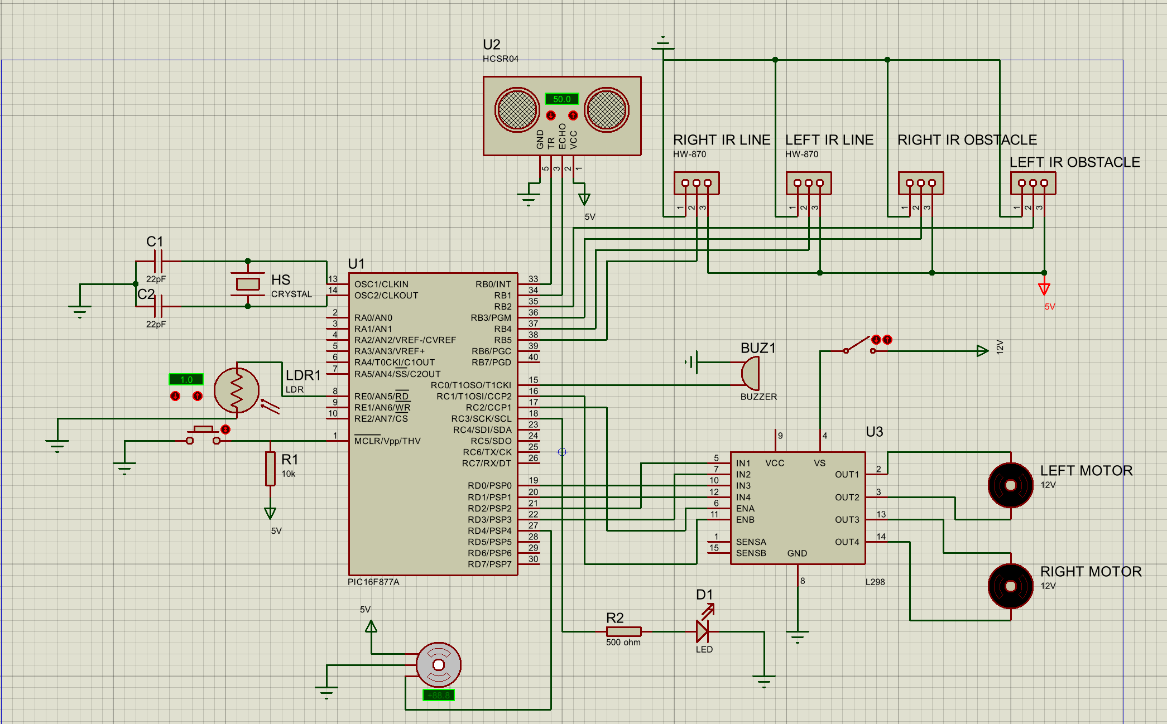
Component | Microcontroller Pin
Left IR Sensor | RB4
Right IR Sensor | RB5
Left IR Obstacle Sensor | RB2
Right IR Obstacle Sensor | RB3
LDR Sensor | RE0
Ultrasonic TRIG | RB0
Ultrasonic Echo | RB1
Motor Driver IN1 | RD2
Motor Driver IN2 | RD3
Motor Driver IN3 | RD0
Motor Driver IN4 | RD1
Motor PWM Left | RC2
Motor PWM Right | RC1
LED | RC3
Buzzer | RC0
Reset Button | MCLR
Servo Motor | RD4
Power Switch | -

Software Design
The software controls all sensing, decision-making, and movement of the robot. It is written in embedded C and runs continuously on the microcontroller. The program begins by configuring all required pins as inputs or outputs and setting up PWM for motor control. The IR sensors, light sensor, and other input modules are initialized so they can be read throughout the operation.
Before the robot starts moving, the software activates a short delay. After that, the LED turns on to show that the robot is active, and the main control loop begins.
Inside the main loop, the program repeatedly performs the following steps:
- Read active sensors
- Decide which action is needed
- Adjust the motors using PWM
- Update the LED and buzzer if needed
This loop runs many times per second so the robot can quickly react to changes in the environment.

Line-Following Behavior
The front IR sensors detect whether the robot is over the black line. Based on the readings:
- Both white: move forward
- Left black, right white: turn left
- Right black, left white: turn right
The software also stores the last valid direction. If both sensors lose the line briefly in sharp bends or near T-shaped sections, the robot continues turning in the last direction until one sensor finds the line again. This allows smooth motion without stopping.

Tunnel Detection and Response
The tunnel is detected using the LDR sensor at the top front of the robot. When the measured light drops below a selected value:
- The buzzer is turned on
- The robot continues following the line
- Speed adjusted for smooth movement
When normal light is detected again, the buzzer turns off and the speed returns to the normal value.

Obstacle Zone Behavior
In the obstacle zone, the robot uses both the ultrasonic sensor and the IR obstacle sensors to detect objects in front of it. When an obstacle is found, the robot slows down, makes a small turn to avoid it, and moves around it safely. After passing the obstacle, it continues forward toward the next zone.

Bump Zone Behavior
The bump is handled using the same line-following logic and stable motor speeds. The robot maintains enough speed to climb the bump without stopping. The software continues using the last known direction if the sensors briefly fluctuate due to vibration. After crossing the bump, the robot returns to normal movement.

Parking Zone Behavior
In the parking zone, the robot detects the final stopping point, slows down, and stops inside the parking area. After stopping, the servo motor lifts a small flag and LED is off to show that the robot has completed the course.

The flowchart:
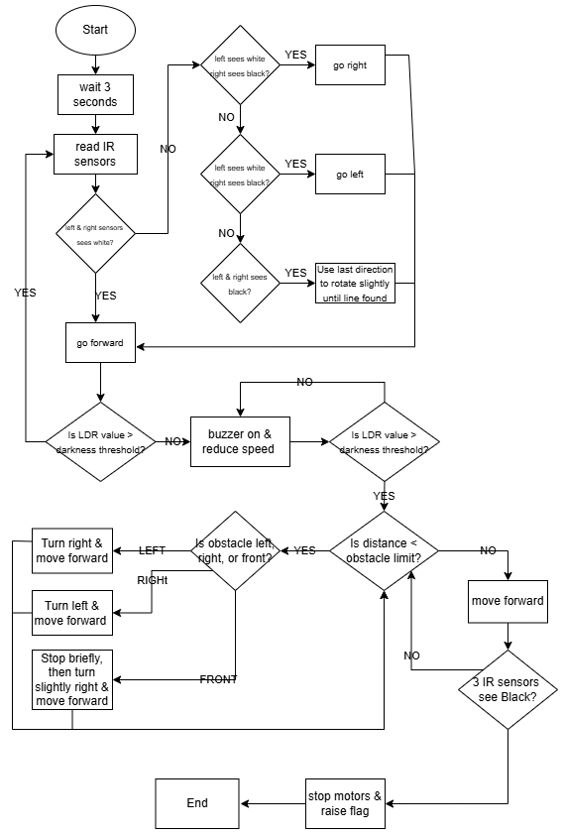

Problems and recommendations
During the development and testing of the autonomous robot, several challenges were identified across the electrical and software aspects of the system. These issues helped improve the final design and provide direction for future enhancements.
1. Sensor Sensitivity and Calibration
Problem: The IR line sensors and the LDR initially produced unstable readings under different lighting conditions, which sometimes caused the robot to lose the line or misdetect tunnel darkness.
Recommendation: Introduce a calibration step at startup or use adjustable potentiometers on the sensor modules to fine-tune sensitivity for different lighting and surface conditions.
2. Obstacle Detection Reliability
Problem: The ultrasonic sensor alone was sometimes unreliable when detecting small or angled obstacles, especially objects that absorbed or scattered sound waves.
Recommendation: Combining ultrasonic and IR obstacle sensors significantly improved detection. Future versions may add additional side sensors or apply filtering to distance readings for more stability.
3. Motor Speed Stability
Problem: Motor performance changed as battery voltage decreased, causing inconsistent speed and turning behavior after extended operation.
Recommendation: Use a dedicated voltage regulator for motor power or implement a battery monitoring algorithm to adjust speeds automatically as voltage levels drop.
4. Bump Zone Performance
Problem: When climbing the bump, vibrations affected sensor readings and caused temporary instability in the steering logic.
Recommendation: Maintain a fixed forward direction during the bump and resume steering corrections only after reaching stable ground. Mechanically, slightly larger wheels can further improve stability.
5. Parking Accuracy
Problem: The robot occasionally stopped slightly ahead or behind the intended parking location due to small variations in timing or sensor response.
Recommendation: Add a small correction step after stopping or use a distinctive track marker at the parking zone to improve repeatability. A dedicated parking sensor could also be used in future versions.
6. Wiring Organization and Space Management
Problem: The number of sensors and modules made wiring complex, and managing all connections on a single breadboard created clutter and made debugging harder.
Recommendation: A second breadboard was added to separate and organize the wiring more clearly. This made troubleshooting easier and reduced accidental disconnections. Future versions could benefit from a custom PCB to minimize wiring and improve reliability.

Results
The robot was evaluated across all zones of the track to verify accuracy, stability, and responsiveness. Testing began in the line-following zone, where the two IR line sensors allowed the robot to follow straight segments and curves smoothly. The robot maintained strong alignment with the track by continuously adjusting motor speeds based on sensor readings.
As the robot approached the tunnel zone, the LDR sensor at the top front detected reduced brightness and triggered the tunnel mode. The robot stayed centered on the line while moving through the darker area, and the buzzer activated to indicate tunnel entry. Once normal lighting returned, the robot automatically reverted to standard operation.
After exiting the tunnel, the robot entered the obstacle-handling zone. Here, the ultrasonic sensor first detected the obstacle ahead and signaled the robot to slow down. As the robot got closer, the additional IR obstacle-detection sensors provided more precise detection of the object’s position. With both sensors working together, the robot executed a controlled avoidance maneuver, changed direction appropriately, and safely navigated around the obstacle. Once the obstacle was fully cleared, the robot returned to the line and continued normally.
In the bump zone, the robot maintained good stability and traction. The selected motor speeds allowed it to climb the raised surface without slipping or losing balance. After crossing the bump, the robot continued in a straight and stable path.
In the parking zone, the robot detected the final stopping area and slowly moved into position. After reaching the correct location, the robot stopped completely and activated the servo motor to raise a small flag, indicating successful completion of the mission. The parking action was smooth, stable, and clearly visible.
Overall, the robot performed reliably throughout all tests. It transitioned smoothly between different zones, detected obstacles accurately using both ultrasonic and IR sensors, handled the tunnel and bump effectively, and completed the parking sequence with the servo flag mechanism.

Conclusion
The project successfully achieved its main goal of designing and implementing an autonomous robot capable of navigating a structured multi-zone track. The robot follows a black line through straight and curved sections, detects and responds to the tunnel using a light sensor, monitors obstacles using an ultrasonic sensor and IR sensors in the obstacle zone, climbs a bump while maintaining balance, and finishes the track by stopping in a defined parking area.
The integration of mechanical design, sensor placement, electrical wiring, and real-time control software resulted in a stable and reliable system. The work provided practical experience in embedded programming, sensor integration, PWM motor control, and problem-solving under real-world constraints.
Future improvements could include adding more sensors for better line detection, implementing more advanced obstacle avoidance strategies, and designing a custom PCB to replace the breadboard wiring.

APPENDEX

YouTube Video Link
https://youtube.com/shorts/XxIld9OJTFw?si=ZRU9irlnRJvpH-QS

GitHub Link
Lara-Qas/Embedded-Project

